- We think official UK GDP data continue to exhibit signs of residual seasonality, which is distorting the growth picture. In each of the past four years, GDP growth was particularly strong in the early months of the year, before momentum collapsed in the second half. So far, 2026 outturns are following a similar pattern.
- Our analysis suggests that the Office for National Statistics’ seasonal adjustment process is not fully accounting for a structural shift in the seasonal pattern of expenditure towards Q1 since the pandemic.
- We expect the ONS’s seasonal adjustment factors will slowly catch up with this development as the sample of post-pandemic data grows. But in the meantime, data users should avoid putting too much emphasis on in-year GDP outturns when assessing economic momentum.
The UK’s most recent GDP release reported that GDP grew 0.5% month-on-month in February, after a modest rise in January. This means that GDP is on course to deliver very strong growth in Q1 2026. Business surveys, meanwhile, showed a wide gap compared with the strength of official data, though they generally reported rising activity.
We think residual seasonality in the GDP data is the most plausible explanation for the gap. The headline GDP series is supposed to be purged of seasonal effects. But in each of the past four years, output growth was stronger in the early months of the year. Output then abruptly slowed in Q3 before reaccelerating in the final months of the year (Chart 1). So far, 2026 data is following a similar pattern.
Chart 1: GDP growth has become suspiciously seasonal since the pandemic
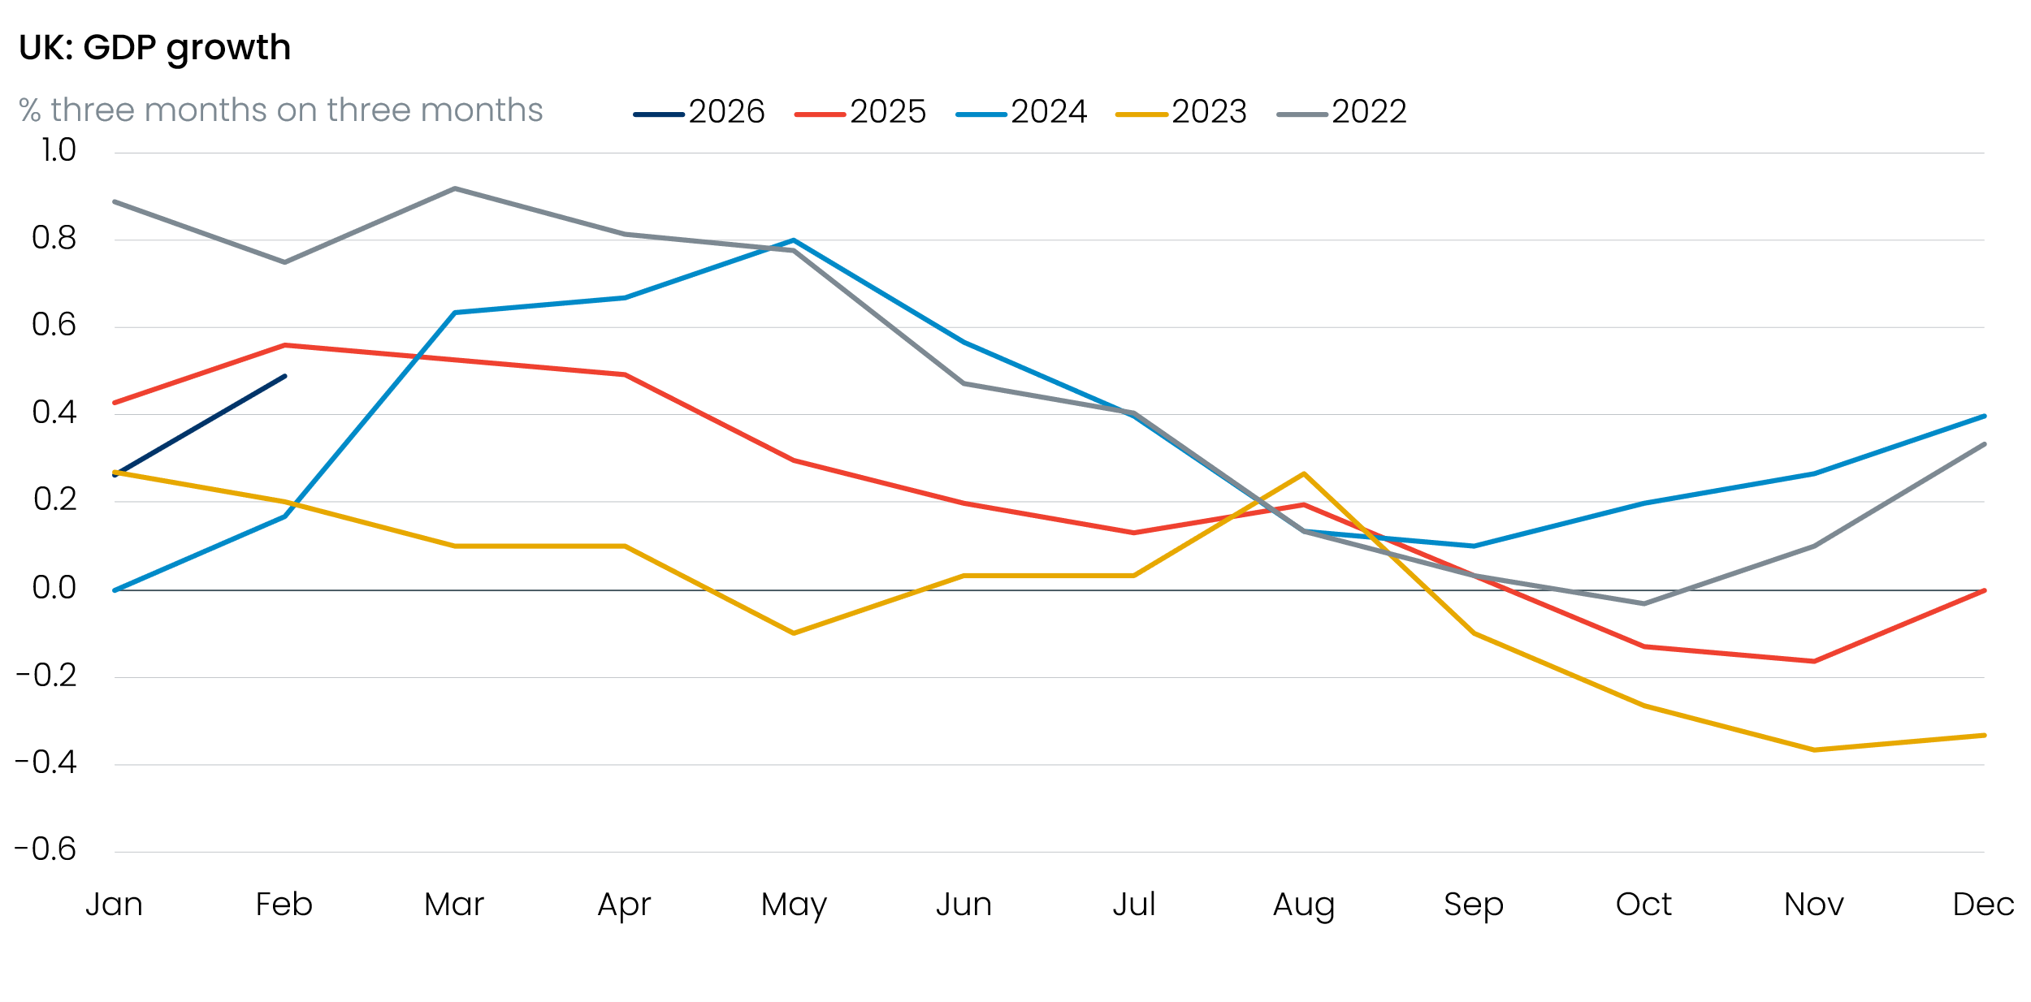
Source: Haver Analytics

Why the ONS’s clean bill of health isn’t convincing
We have highlighted our concerns that the UK’s output data has looked increasingly seasonal for over a year, and that structural changes to seasonal activity patterns since the pandemic are likely to blame. Last September, the ONS sought to allay mounting concerns over its seasonal adjustment process by publishing a research note that found no evidence of residual seasonality in its GDP estimates.
While the statistical tests employed by the ONS are valid, we think there are significant limitations to its approach. In particular, most of the tests used are only well-suited to capturing residual seasonality that is stable and persistent across an entire sample. Meanwhile, the ONS’s more advanced testing procedures, which examine whether seasonality has evolved using five-year windows, are constrained by the small post-pandemic sample and therefore struggle to adapt quickly enough to reliably detect recent seasonal pattern changes.
Given that none of the ONS’s approaches are well-suited to detecting recent structural breaks in seasonal patterns when that break coincides with a period of significant economic volatility, we don’t think its findings refute the argument that residual seasonality has emerged since the pandemic.

We find a shift in activity to Q1, potentially concentrated in business investment
Beyond the distinct pattern that has emerged in the headline activity data, we think one of the clearest pieces of evidence of a shift in the seasonal profile of GDP can be found in the non-seasonally adjusted series. We compared non-seasonally adjusted GDP to a seven-quarter centred moving average. This is essentially a smooth measure of unadjusted activity in a given quarter relative to other quarters. This analysis shows Q1 has gone from being consistently one of the weaker quarters to now being one of the strongest since the pandemic (Chart 2).
Chart 2: GDP data pre-seasonal filtering is now more geared towards Q1 than before the pandemic
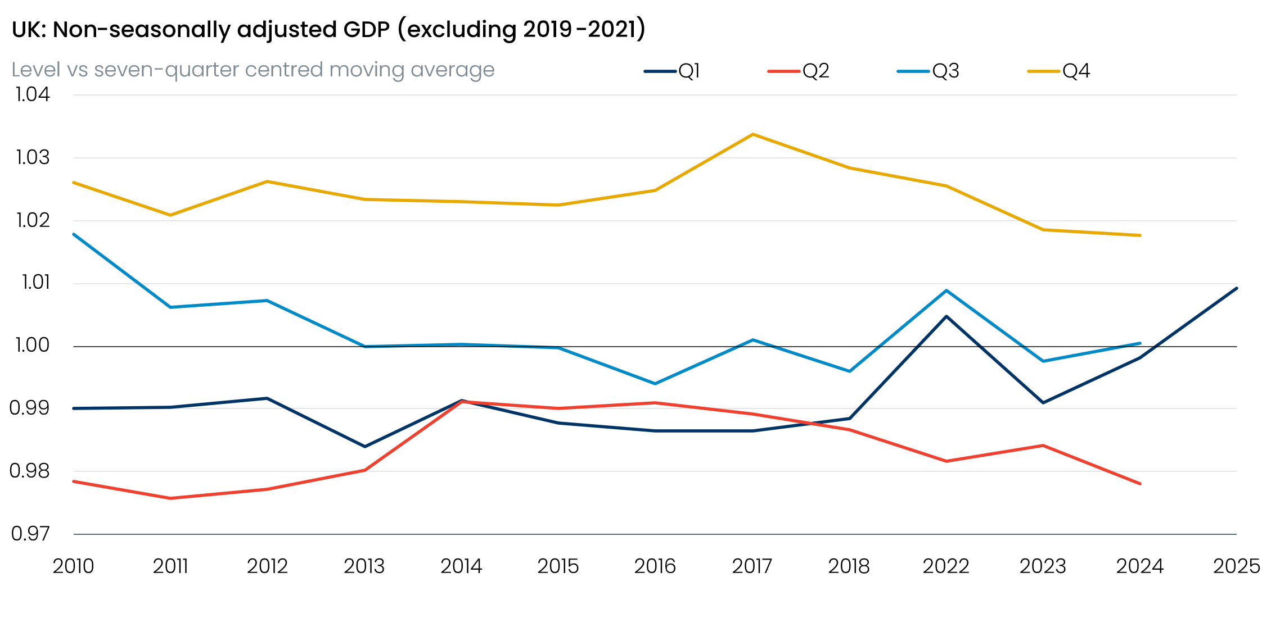
Sources: Oxford Economics, Haver Analytics
We see the same regime shift in the nominal data as we do on the real side, which suggests the deflators are unlikely to be the cause.
We’ve conducted the same analysis on the expenditure components of GDP. This shows similar changes in the seasonal pattern of business investment, with investment in non-residential buildings, ICT and machinery equipment, and intellectual property now more focused in the early months of the year than prior to the pandemic. However, business investment is a notoriously volatile and heavily revised series, so we remain cautious about the precise driver of the phenomenon.
Differences in the seasonal pattern of expenditure throughout the year are what any seasonal adjustment process needs to absorb. As we move further from the pandemic, the ONS’s seasonal filters do appear to be responding. The ratio of seasonally adjusted GDP to its non-seasonally adjusted counterpart provides a helpful gauge of how much work the adjustment process is doing.
Throughout the 2010-2019 period, the ratio was consistently positive in Q1, meaning that recorded activity had typically been weak in Q1 and the ONS had been adjusting the raw data higher (Chart 3). This trend has flipped in recent years, signalling that the ONS’s seasonal filters have started to adjust Q1 lower. But given that seasonally adjusted Q1 GDP has remained very strong during these years, and the 2026 data looks set to follow the same pattern, these downward adjustments likely aren’t going far enough.
Chart 3: The ONS’s practice of lifting unseasonably weak raw Q1 activity has reversed in recent years
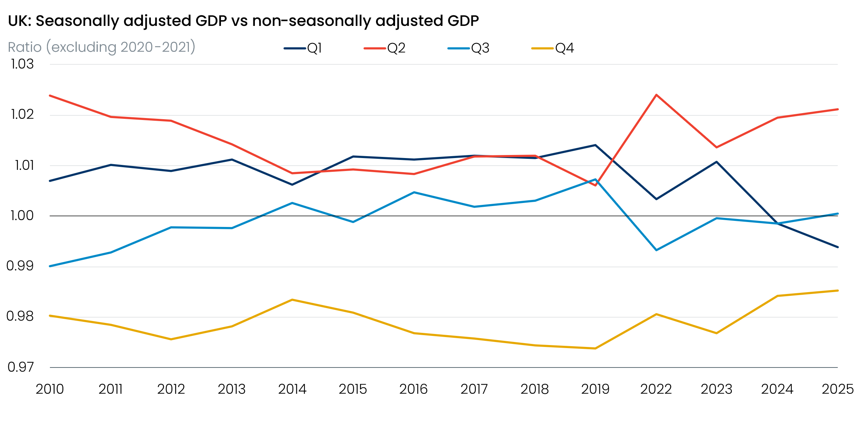
Sources: Oxford Economics, Haver Analytics
We’ve found that the ONS’s downward adjustments to Q1 in recent years have increasingly been concentrated in investment expenditure. Therefore, it appears the seasonal adjustment process is responding to where the shift in the seasonal pattern of underlying activity is coming from. But as with the headline picture, the magnitude of these downward adjustments is insufficient to fully offset the unusually strong Q1 outturns we’ve seen since the pandemic.

How to read the GDP data until the ONS catches up
We suspect the ONS’s seasonal adjustment factors will increasingly adjust to the shift in underlying activity towards Q1 as the sample of post-pandemic data grows. Therefore, the residual seasonality present in the GDP series should subside over time, with output likely to become more evenly distributed throughout the year. But until then, we would urge clients and policymakers to treat in-year GDP outturns with some caution and not put too much emphasis on the apparent strength of Q1 readings or collapses in momentum in subsequent quarters.
Beyond our concerns about the reliability of the GDP data, several other well-publicised problems with official economic statistics for the UK continue to cloud the economic picture. These include the ONS Labour Force Survey and the delayed introduction of the Transformed Labour Force Survey, the population and migration estimates, and the trade data. Together, these ongoing quality issues in the official data demonstrate the value of incorporating a broader range of alternative data sources when examining current economic conditions and assessing where risks in the official data may lie.

